Find the variance for the following set of data representing trees in California (heights in feet):

3, 21, 98, 203, 17, 9

Solutions:

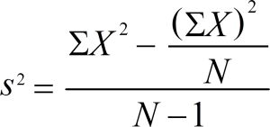

**Step 1**: Add up the numbers in your given data set.

3 + 21 + 98 + 203 + 17 + 9 = 351

**Step 2**: Square your answer:

351 × 351 = 123,201

…and divide by the number of items. We have 6 items in our example so:

123,201 / 6 = 20,533.5

Set this number aside for a moment.

**Step 3**: Take your set of original numbers from Step 1, and square them individually this time:

3 × 3 + 21 × 21 + 98 × 98 + 203 × 203 + 17 × 17 + 9 × 9

Add those numbers (the squares) together:

9 + 441 + 9604 + 41209 + 289 + 81 = 51,633

**Step 4**: Subtract the amount in Step 2 from the amount in Step 3.

51,633 – 20,533.5 = 31,099.5

Set this number aside for a moment.

**Step 5**: Subtract 1 from the number of items in your data set*. For our example:

6 – 1 = 5

**Step 6**: Divide the number in Step 4 by the number in Step 5. This gives you the **variance**:

31,099.5 / 5 = **6,219.9**